3GPP TS 38.300 V0.2.1 (2017-05)
Technical Specification
3rd Generation Partnership Project;
Technical Specification Group Radio Access Network;
NR;
NR and NG-RAN Overall Description;
Stage 2
(Release 15)


The present document has been developed within the 3rd Generation Partnership Project (3GPP TM) and may be further elaborated for the purposes of 3GPP..
The present document has not been subject to any approval process by the 3GPP Organizational Partners and shall not be implemented.
This Specification is provided for future development work within 3GPP only. The Organizational Partners accept no liability for any use of this Specification.
Specifications and Reports for implementation of the 3GPP TM system should be obtained via the 3GPP Organizational Partners' Publications Offices.

Keywords
3GPP, Radio, Architecture, Stage 2, 5G
3GPP
Postal address

3GPP support office address
650 Route des Lucioles - Sophia Antipolis
Valbonne - FRANCE
Tel.: +33 4 92 94 42 00 Fax: +33 4 93 65 47 16
Internet
http://www.3gpp.org
Copyright Notification
No part may be reproduced except as authorized by written permission.
The copyright and the foregoing restriction extend to reproduction in all media.

© 2017, 3GPP Organizational Partners (ARIB, ATIS, CCSA, ETSI, TSDSI, TTA, TTC).
All rights reserved.

UMTS™ is a Trade Mark of ETSI registered for the benefit of its members
3GPP™ is a Trade Mark of ETSI registered for the benefit of its Members and of the 3GPP Organizational Partners
LTE™ is a Trade Mark of ETSI registered for the benefit of its Members and of the 3GPP Organizational Partners
GSM® and the GSM logo are registered and owned by the GSM Association
Contents
Foreword 6
1 Scope 7
2 References 7
3 Abbreviations and Definitions 7
3.1 Abbreviations 7
3.2 Definitions 7
4 Overall Architecture and Functional Split 8
4.1 Overall Architecture 8
4.2 Functional Split 9
4.3 Network Interfaces 11
4.3.1 NG Interface 11
4.3.1.1 NG User Plane 11
4.3.1.1 NG Control Plane 11
4.3.2 Xn Interface 12
4.3.2.1 Xn User Plane 12
4.3.2.2 Xn Control Plane 12
4.4 Radio Protocol Architecture 13
4.4.1 User Plane 13
4.4.2 Control Plane 13
4.5 Dual Connectivity 14
4.5.1 General 14
4.5.2 Radio Protocol Architecture 14
4.5.3 Network Interfaces 15
5 Physical Layer 15
6 Layer 2 15
6.1 Overview 15
6.2 MAC Sublayer 17
6.2.1 Services and Functions 17
6.2.2 Logical Channels 17
6.2.3 Mapping to Transport Channels 17
6.2.4 HARQ 18
6.3 RLC Sublayer 18
6.3.1 Transmission Modes 18
6.3.2 Services and Functions 18
6.3.3 ARQ 18
6.4 PDCP Sublayer 19
6.4.1 Services and Functions 19
6.4.2 Duplication 19
6.5 SDAP Sublayer 19
6.6 L2 Data Flow 20
6.7 Carrier Aggregation 20
6.8 Dual Connectivity 22
7 RRC 22
7.1 Services and Functions 22
7.2 Protocol States 23
7.3 System Information Handling 24
7.4 Access Control 24
7.5 UE Capability Retrieval framework 25
7.6 Transport of NAS Messages 25
7.7 Carrier Aggregation 25
8 NG Identities 25
9 Mobility and State Transitions 25
9.1 Overview 25
9.2 Intra-NR 26
9.2.1 Mobility in RRC_IDLE 26
9.2.1.1 Cell Selection 26
9.2.1.2 Cell Reselection 27
9.2.2 Mobility in RRC_INACTIVE 27
9.2.2.1 Cell Reselection 27
9.2.2.2 RAN-Based Notification Area 27
9.2.2.3 State Transitions 28
9.2.2.3.1 UE triggered transition from RRC_INACTIVE to RRC_ACTIVE 28
9.2.2.3.2 Network triggered transition from RRC_INACTIVE to RRC_ACTIVE 28
9.2.3 Mobility in RRC_CONNECTED 29
9.2.3.1 Overview 29
9.2.3.2 Handover 30
9.2.3.2.1 C-Plane Handling 30
9.2.3.2.2 U-Plane Handling 32
9.2.4 Measurements 32
9.2.5 Paging 32
9.2.6 Random Access Procedure 32
9.2.7 Radio Link Failure 33
9.3 Inter RAT 33
9.3.1 Cell Reselection 33
9.3.2 Handover 34
9.3.3 Measurements 34
9.4 Roaming and Access Restrictions 34
10 Scheduling 34
10.1 Basic Scheduler Operation 34
10.2 Downlink Scheduling 35
10.3 Uplink Scheduling 35
10.4 Measurements to Support Scheduler Operation 35
10.5 Rate Control 35
10.6 Activation/Deactivation Mechanism 36
11 UE Power Saving 36
12 QoS 36
13 Security 38
14 Network Interfaces 38
15 CU/DU Split 38
16 UE Capabilities 38
17 Verticals Support 38
17.1 Self-Configuration and Self-Optimisation 38
17.1.1 Definitions 38
17.1.2 UE Support for self-configuration and self-optimisation 38
17.1.3 Self-configuration 38
17.1.3.1 Dynamic configuration of the NG-C interface 38
17.1.3.1.1 Prerequisites 38
17.1.3.1.2 SCTP initialization 39
17.1.3.1.3 Application layer initialization 39
17.1.3.2 Dynamic Configuration of the Xn interface 39
17.1.3.2.1 Prerequisites 39
17.1.3.2.2 SCTP initialization 39
17.1.3.2.3 Application layer initialization 39
17.1.3.3 Automatic Neighbour Relation Function 39
17.1.3.3.1 General 39
17.1.3.3.2 Intra-system – intra NR Automatic Neighbour Relation Function 40
17.1.3.3.3 Intra-system – intra E-UTRA Automatic Neighbour Relation Function 40
17.1.3.3.4 Intra-system – inter RAT Automatic Neighbour Relation Function 40
17.1.3.3.5 Inter-system Automatic Neighbour Relation Function 40
17.1.3.4 Xn-C TNL address discovery 40
17.2 IMS Voice 40
17.3 Network Slicing 40
17.3.1 General Principles and Requirements 40
17.3.2 CN Instance and NW Slice Selection 42
17.3.2.1 CN-RAN interaction and internal RAN aspects 42
17.3.2.2 Radio Interface Aspects 42
17.3.3 Resource Isolation and Management 42
17.3.4 Signalling Aspects 42
17.3.4.1 General 42
17.3.4.2 CN Instance and NW Slice Selection 42
17.3.4.3 UE Context Handling 43
17.3.4.4 PDU Session Handling 44
17.3.4.5 Mobility 45
17.3 PWS 46
17.4 URLLC 46
Annex Z (informative): Change history 47

Foreword
This Technical Specification has been produced by the 3rd Generation Partnership Project (3GPP).
The contents of the present document are subject to continuing work within the TSG and may change following formal TSG approval. Should the TSG modify the contents of the present document, it will be re-released by the TSG with an identifying change of release date and an increase in version number as follows:
Version x.y.z
where:
x the first digit:
1 presented to TSG for information;
2 presented to TSG for approval;
3 or greater indicates TSG approved document under change control.
y the second digit is incremented for all changes of substance, i.e. technical enhancements, corrections, updates, etc.
z the third digit is incremented when editorial only changes have been incorporated in the document.

1 Scope
The present document provides an overview and overall description of the NG-RAN and focuses on the radio interface protocol architecture of NR connected to 5GC (E-UTRA connected to 5GC is covered in the 36 series). Details of the radio interface protocols are specified in companion specifications of the 38 series.

2 References
The following documents contain provisions which, through reference in this text, constitute provisions of the present document.
- References are either specific (identified by date of publication, edition number, version number, etc.) or non-specific.
- For a specific reference, subsequent revisions do not apply.
- For a non-specific reference, the latest version applies. In the case of a reference to a 3GPP document (including a GSM document), a non-specific reference implicitly refers to the latest version of that document in the same Release as the present document.
[1] 3GPP TR 21.905: "Vocabulary for 3GPP Specifications".
[2] 3GPP TS 36.300: "Evolved Universal Terrestrial Radio Access (E-UTRA) and Evolved Universal Terrestrial Radio Access Network (E-UTRAN); Overall description; Stage 2".
[3] 3GPP TS 23.501: "System Architecture for the 5G System; Stage 2".

3 Abbreviations and Definitions

3.1 Abbreviations
For the purposes of the present document, the abbreviations given in 3GPP TR 21.905 [1], in 3GPP TS 36.300 [2] and the following apply. An abbreviation defined in the present document takes precedence over the definition of the same abbreviation, if any, in 3GPP TR 21.905 [1] and 3GPP TS 36.300 [2].
5GC 5G Core Network
AMF Access and Mobility Management Function
gNB NR NodeB
NG-RAN NG Radio Access Network
NR NR Radio Access
SDAP Service Data Adaptation Protocol
SMF Session Management Function
UPF User Plane Function
Xn-C Xn-Control plane
Xn-U Xn-User plane

3.2 Definitions
For the purposes of the present document, the terms and definitions given in 3GPP TR 21.905 [1], in 3GPP TS 36.300 [2] and the following apply. A term defined in the present document takes precedence over the definition of the same term, if any, in 3GPP TR 21.905 [1] and 3GPP TS 36.300 [2].
Master gNB: in dual connectivity, the gNB which terminates at least NG-C.
MCG bearer: in dual connectivity, a bearer whose radio protocols are only located in the MCG.
MCG split bearer: in dual connectivity, a bearer whose radio protocols are split at the MgNB and belong to both MCG and SCG.
MSG1: preamble transmission of the random access procedure.
MSG3: first scheduled transmission of the random access procedure.
NG-C: control plane interface between NG-RAN and 5GC.
NG-U: user plane interface between NG-RAN and 5GC.
Numerology: corresponds to one subcarrier spacing in the frequency domain. By scaling a reference subcarrier spacing by an integer N, different numerologies can be defined.
SCG bearer: in dual connectivity, a bearer whose radio protocols are only located in the SCG.
SCG split bearer: in dual connectivity, a bearer whose radio protocols are split at the SgNB and belong to both SCG and MCG.
Secondary gNB: in dual connectivity, the gNB that is providing additional radio resources for the UE but is not the Master node.
TTI duration: corresponds to a number of consecutive symbols in the time domain in one transmission direction. Different TTI durations can be defined when using different number of symbols.
Xn: network interface between gNBs and/or eNBs connected to 5GC.

4 Overall Architecture and Functional Split

4.1 Overall Architecture
The New Generation Access Network (NG-RAN) consists of gNBs and/or eNBs, providing the user plane and control plane protocol terminations towards the UE. The gNBs and eNBs are interconnected with each other by means of the Xn interface. The gNBs and eNBs are also connected by means of the NG interfaces to the 5GC, more specifically to the AMF (Access and Mobility Management Function) by means of the NG-C interface and to the UPF (User Plane Function) by means of the NG-U interface (see 3GPP TS 23.501 [3]).
The NG-RAN architecture with gNBs is illustrated in Figure 4.1-1 below. The NG-RAN architecture with eNBs is depicted in 3GPP TS 36.300 [2].
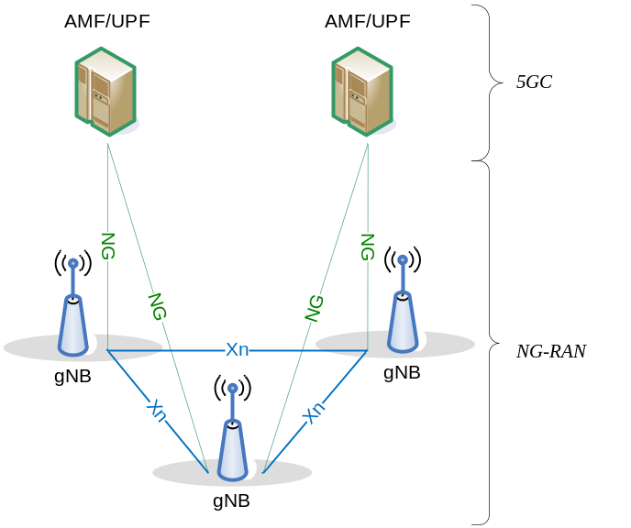
Figure 4.1-1: Overall Architecture

4.2 Functional Split
The gNB hosts the following functions:
- Functions for Radio Resource Management: Radio Bearer Control, Radio Admission Control, Connection Mobility Control, Dynamic allocation of resources to UEs in both uplink and downlink (scheduling);
- IP header compression, encryption of user data stream and integrity protection;
- Selection of an AMF at UE attachment when no routing to an AMF can be determined from the information provided by the UE;
- Routing of User Plane data towards UPF(s);
- Routing of Control Plane information towards AMF;
- Connection setup and release;
- Scheduling and transmission of paging messages (originated from the AMF);
- Scheduling and transmission of system broadcast information (originated from the AMF or O&M);
- Measurement and measurement reporting configuration for mobility and scheduling;
- Transport level packet marking in the uplink;
- Session Management;
- Support of Network Slicing;
- QoS Flow management and mapping to data radio bearers;
- Support of UEs in inactive mode;
- Distribution function for NAS messages;
- NAS node selection function;
- Radio access network sharing;
- Dual Connectivity;
- Tight interworking between NR and E-UTRA.
The AMF hosts the following main functions (see 3GPP TS 23.501 [3]):
- NAS signalling termination;
- NAS signalling security;
- AS Security control;
- Inter CN node signalling for mobility between 3GPP access networks;
- Idle mode UE Reachability (including control and execution of paging retransmission);
- Registration Area management;

- Support of intra-system and inter-system mobility;
- Access Authentication;
- Access Authorization including check of roaming rights;
- Mobility management control (subscription and policies);
- Support of Network Slicing;
- SMF selection.
The UPF hosts the following main functions (see 3GPP TS 23.501 [3]):
- Anchor point for Intra-/Inter-RAT mobility (when applicable);
- External PDU session point of interconnect to Data Network;
- Packet routing & forwarding;
- Packet inspection and User plane part of Policy rule enforcement;
- Traffic usage reporting;
- Uplink classifier to support routing traffic flows to a data network;
- Branching point to support multi-homed PDU session;
- QoS handling for user plane, e.g. packet filtering, gating, UL/DL rate enforcement;
- Uplink Traffic verification (SDF to QoS flow mapping);

- Downlink packet buffering and downlink data notification triggering.
The Session Management function (SMF) hosts the following main functions (see 3GPP TS 23.501 [3]):
- Session Management;
- UE IP address allocation and management;
- Selection and control of UP function;
- Configures traffic steering at UPF to route traffic to proper destination;
- Control part of policy enforcement and QoS;
- Downlink Data Notification.
This is summarized on the figure below where yellow boxes depict the logical nodes and white boxes depict the main functions.
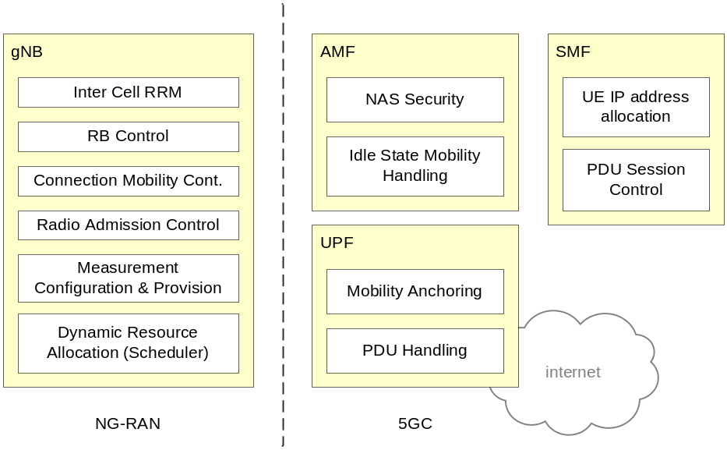
Figure 4.2-1: Functional Split between NG-RAN and 5GC

4.3 Network Interfaces

4.3.1 NG Interface

4.3.1.1 NG User Plane
The NG user plane interface (NG-U) is defined between the gNB/eNB and the UPF. The user plane protocol stack of the NG interface is shown on Figure 4.3.1.1-1. The transport network layer is built on IP transport and GTP-U is used on top of UDP/IP to carry the user plane PDUs between the gNB/eNB and the UPF.
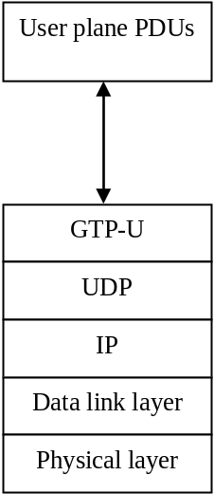
Figure 4.3.1.2-1: NG-U Protocol Stack
NG-U provides non-guaranteed delivery of user plane PDUs between the gNB/eNB and the UPF.

4.3.1.1 NG Control Plane
The NG control plane interface (NG-C) is defined between the gNB/eNB and the AMF. The control plane protocol stack of the NG interface is shown on Figure 4.3.1.2-1. The transport network layer is built on IP transport. For the reliable transport of signalling messages, SCTP is added on top of IP. The application layer signalling protocol is referred to as NG-AP (NG Application Protocol). The SCTP layer provides guaranteed delivery of application layer messages. In the transport, IP layer point-to-point transmission is used to deliver the signalling PDUs.
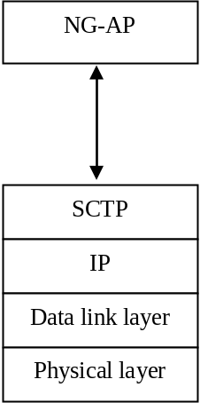
Figure 4.3.1.2-1: NG-C Protocol Stack
NG-C provides the following functions:
- Interface management: the functionality to manage the NG-C interface;
- UE context management: the functionality to manage the UE context between NG-RAN and 5GC;
- UE mobility management: the functionality to manage the UE mobility for connected mode between NG-RAN and 5GC;
- Transport of NAS messages: procedures to transfer NAS messages between 5GC and UE;
- Paging: the functionality to enable 5GC to generate paging messages sent to NG-RAN and to allow NG-RAN to page the UE in RRC_IDLE state;
- PDU Session Management: the functionality to establish, manage and remove PDU sessions and respective NG-RAN resources that are made of data flows carrying UP traffic;
- Configuration Transfer: the functionality to transfer the NG-RAN configuration information (e.g. transport layer addresses for establishment of Xn interface) between two NG-RAN nodes via t5GC;
- Warning Message Transmission: this functionality provides the means to start and overwrite the broadcasting of warning message (FFS).

4.3.2 Xn Interface
The node name in this section is FFS.

4.3.2.1 Xn User Plane
The Xn User plane (Xn-U) interface is defined between two gNBs connecting to 5GC, between gNB and eNB connecting to 5GC and between two eNBs connecting to 5GC. The user plane protocol stack on the Xn interface is shown in Figure 4.3.2.1-1. The transport network layer is built on IP transport and GTP-U is used on top of UDP/IP to carry the user plane PDUs.
Figure 4.3.2.1-1: Xn-U Protocol Stack
Xn-U provides non-guaranteed delivery of user plane PDUs and supports the following functions:
- Data forwarding;
- Flow control.

4.3.2.2 Xn Control Plane
The Xn control plane interface (Xn-C) is defined between two gNBs connecting to 5GC, between gNB and eNB connecting to 5GC and between two eNBs connecting to 5GC. The control plane protocol stack of the Xn interface is shown on Figure 4.3.2.2-1. The transport network layer is built on SCTP on top of IP. The application layer signalling protocol is referred to as Xn-AP (Xn Application Protocol). The SCTP layer provides the guaranteed delivery of application layer messages. In the transport IP layer point-to-point transmission is used to deliver the signalling PDUs.
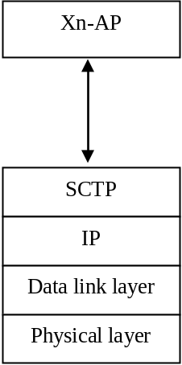
Figure 4.3.2.2-1: Xn-C Protocol Stack
The Xn-C interface supports the following functions:
- Xn interface management and error handling: the functionality to manage the Xn-C interface;
- Mobility support for UE in CM-CONNECTED: the functionality to manage the UE mobility for connected mode between nodes in the NG-RAN;
- Dual connectivity: the functionality to enable usage of additional resources in a secondary node in the NG-RAN.

4.4 Radio Protocol Architecture

4.4.1 User Plane
The figure below shows the protocol stack for the user plane, where SDAP, PDCP, RLC and MAC sublayers (terminated in gNB on the network side) perform the functions listed in subclause 7.
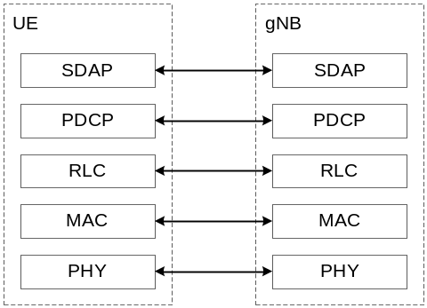
Figure 4.4.1-1: User Plane Protocol Stack

4.4.2 Control Plane
The figure below shows the protocol stack for the control plane, where:
- PDCP, RLC and MAC sublayers (terminated in gNB on the network side) perform the functions listed in subclause 7;
- RRC (terminated in gNB on the network side) performs the functions listed in subclause 8;
- NAS control protocol (terminated in AMF on the network side) performs the functions listed in 3GPP TS 23.501 [3]), for instance: authentication, mobility management, security control…
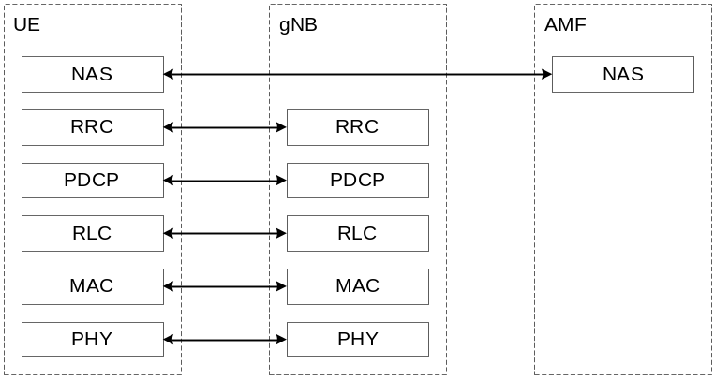
Figure 4.4.2-1: Control Plane Protocol Stack

4.5 Dual Connectivity

4.5.1 General
NR supports Dual Connectivity (DC) operation whereby a UE in RRC_CONNECTED is configured to utilise radio resources provided by two distinct schedulers, located in two gNBs connected via a non-ideal backhaul. gNBs involved in DC for a certain UE may assume two different roles: a gNB may either act as an MgNB or as an SgNB. In DC, a UE is connected to one MgNB and one SgNB.

4.5.2 Radio Protocol Architecture
In DC, the radio protocol architecture that a radio bearer uses depends on how the radio bearer is setup. Four bearer types exist: MCG bearer, MCG split bearer, SCG bearer and SCG split bearer. Those four bearer types are depicted on Figure 4.5.2-1 and 4.5.2-2 below.
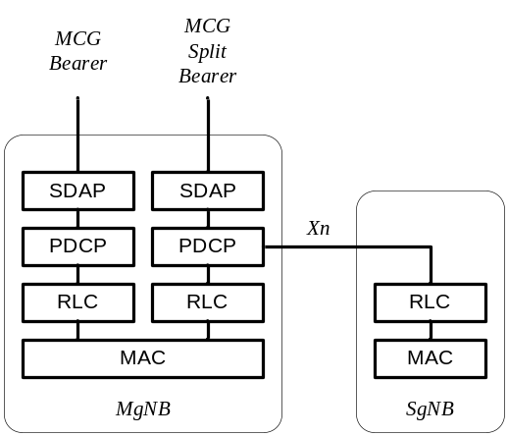
Figure 4.5.2-1: MgNB Bearers for Dual Connectivity
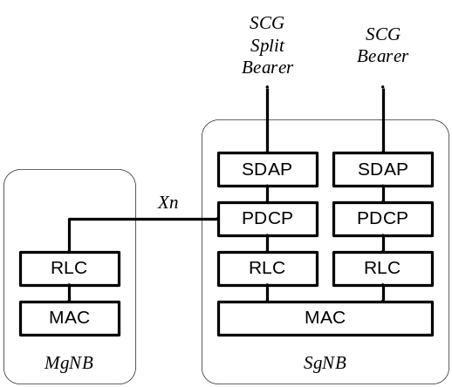
Figure 4.5.2-2: SgNB Bearers for Dual Connectivity

4.5.3 Network Interfaces
To be provided in cooperation with RAN3.

5 Physical Layer
To be provided by RAN1. Should at least contain an overview of downlink & uplink transmission schemes, beam management, channel structure, transport channels, mapping between transport channels and physical channels, definition of slots...

6 Layer 2

6.1 Overview
The layer 2 is split into the following sublayers: Medium Access Control (MAC), Radio Link Control (RLC), Packet Data Convergence Protocol (PDCP) and SDAP (Service Data Adaptation Protocol). The two figures below depict the Layer 2 architecture for downlink and uplink, where:
- The physical layer offers to the MAC sublayer transport channels;
- The MAC sublayer offers to the RLC sublayer logical channels;
- The RLC sublayer offers to the PDCP sublayer RLC channels;
- The PDCP sublayer offers to the SDAP sublayer radio bearers;
- The SDAP sublayer offers to 5GC QoS flows.
- Comp. refers to header compression and segm. to segmentation.
- Control channels (BCCH, PCCH are not depicted for clarity).
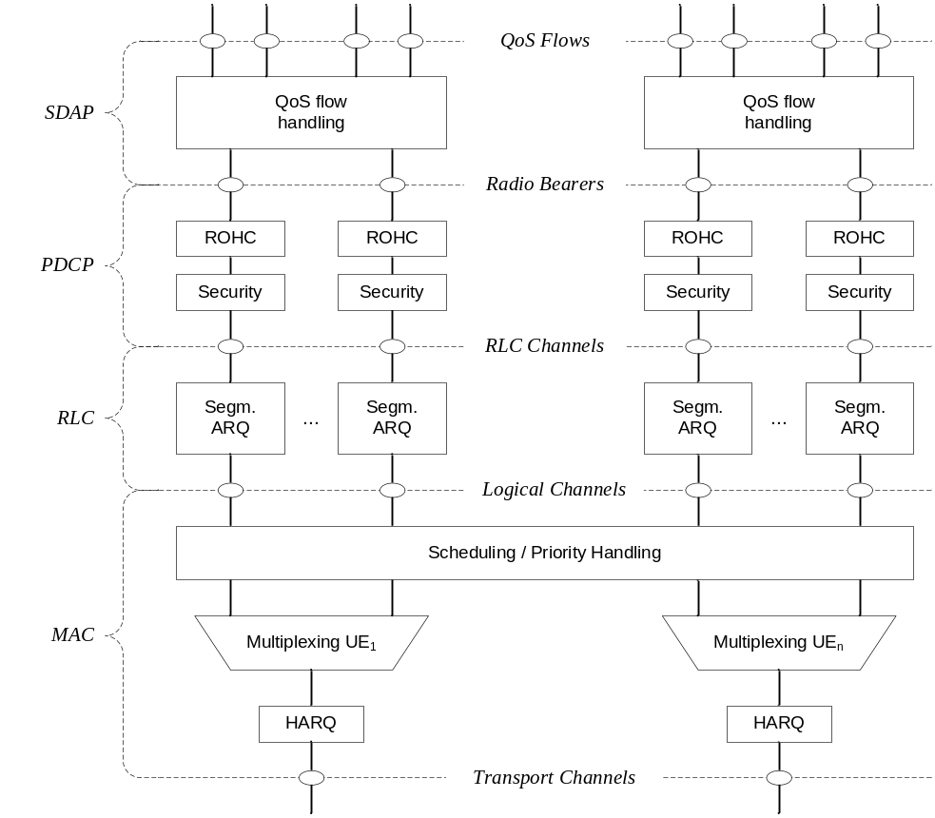
Figure 6.1-1: Downlink Layer 2 Structure
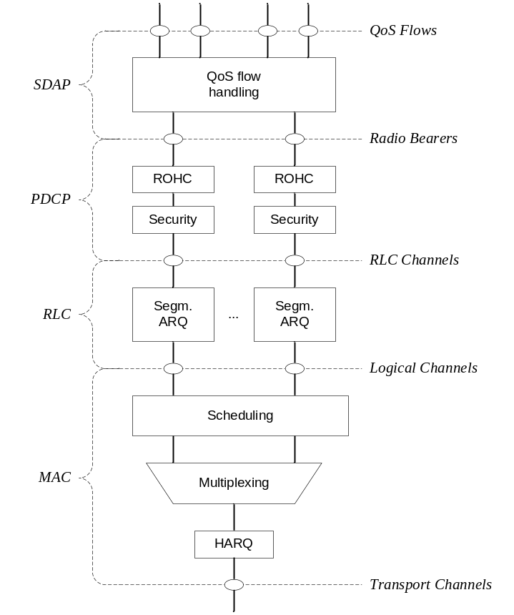
Figure 6.1-2: Uplink Layer 2 Structure
Radio bearers are categorized into two groups: data radio bearers (DRB) for user plane data and signalling radio bearers (SRB) for control plane data.

6.2 MAC Sublayer

6.2.1 Services and Functions
The main services and functions of the MAC sublayer include:
- Mapping between logical channels and transport channels;
- Multiplexing/demultiplexing of MAC SDUs belonging to one or different logical channels into/from transport blocks (TB) delivered to/from the physical layer on transport channels;
- Scheduling information reporting;
- Error correction through HARQ;
- Priority handling between UEs by means of dynamic scheduling;
- Priority handling between logical channels of one UE by means of logical channel prioritisation;
- Padding.
A single MAC entity can support one or multiple numerologies and/or TTI durations but in order for the mapping to be respected, logical channel prioritization procedure takes into account the mapping of one logical channel to one or more numerologies and/or TTI durations.

6.2.2 Logical Channels
Different kinds of data transfer services as offered by MAC. Each logical channel type is defined by what type of information is transferred. Logical channels are classified into two groups: Control Channels and Traffic Channels. Control channels are used for the transfer of control plane information only:
- Broadcast Control Channel (BCCH): a downlink channel for broadcasting system control information.
- Paging Control Channel (PCCH): a downlink channel that transfers paging information and system information change notifications.
- Common Control Channel (CCCH): channel for transmitting control information between UEs and network. This channel is used for UEs having no RRC connection with the network.
To be clarified whether CCCH applies to RRC-Inactive.
- Dedicated Control Channel (DCCH): a point-to-point bi-directional channel that transmits dedicated control information between a UE and the network. Used by UEs having an RRC connection.
Traffic channels are used for the transfer of user plane information only:
- Dedicated Traffic Channel (DTCH): point-to-point channel, dedicated to one UE, for the transfer of user information. A DTCH can exist in both uplink and downlink.

6.2.3 Mapping to Transport Channels
In Downlink, the following connections between logical channels and transport channels exist:
- BCCH can be mapped to BCH;
- BCCH can be mapped to DL-SCH;
- PCCH can be mapped to PCH;
- CCCH can be mapped to DL-SCH;
- DCCH can be mapped to DL-SCH;
- DTCH can be mapped to DL-SCH.
In Uplink, the following connections between logical channels and transport channels exist:
- CCCH can be mapped to UL-SCH;
- DCCH can be mapped to UL- SCH;
- DTCH can be mapped to UL-SCH.

6.2.4 HARQ
The HARQ functionality ensures delivery between peer entities at Layer 1.
More details can be captured once agreed (RAN1 input required).

6.3 RLC Sublayer

6.3.1 Transmission Modes
The RLC sublayer supports three transmission modes:
- Transparent Mode (TM);
- Unacknowledged Mode (UM);
- Acknowledged Mode (AM).
The RLC configuration is per logical channel with no dependency on numerologies and/or TTI durations, and ARQ can operate on any of the numerologies and/or TTI durations the logical channel is configured with.
For SRBs, either TM or AM mode used while for DRBs, it is either UM or AM.

6.3.2 Services and Functions
The main services and functions of the RLC sublayer depend on the transmission mode and include:
- Transfer of upper layer PDUs;
- Sequence numbering independent of the one in PDCP;
- Error Correction through ARQ;
- Segmentation and re-segmentation;
FFS whether re-segmentation applies to PDU or SDU.
- Reassembly of SDU;
- RLC SDU discard;
- RLC re-establishment.

6.3.3 ARQ
The ARQ functionality provides error correction in AM mode
Stage 2 Details of ARQ operation are FFS.

6.4 PDCP Sublayer

6.4.1 Services and Functions
The main services and functions of the PDCP sublayer for the user plane include:
- Sequence Numbering;
- Header compression and decompression: ROHC only;
- Transfer of user data;
- Reordering and duplicate detection (if in order delivery to layers above PDCP is required);
FFS if reordering can be disabled.
- PDCP PDU routing (in case of split bearers);
- Retransmission of PDCP SDUs;
FFS when to perform retransmission.
- Ciphering and deciphering;
FFS whether integrity protection also applies to user plane.
- PDCP SDU discard;
- PDCP re-establishment and data recovery for RLC AM;
- Duplication of PDCP PDUs.
The main services and functions of the PDCP sublayer for the control plane include:
- Sequence Numbering;
- Ciphering, deciphering and integrity protection;
- Transfer of control plane data;
- Duplicate detection;
- Duplication of PDCP PDUs.

6.4.2 Duplication
When duplication is configured for a radio bearer by RRC, an additional RLC entity and an additional logical channel are added to the radio bearer to handle the duplicated PDCP PDUs. Duplication at PDCP therefore consists in sending the same PDCP PDUs twice: once on the original RLC entity and a second time on the additional RLC entity. When doing so, the original PDCP PDU and the corresponding duplicate shall not be transmitted on the same transport block. The two different logical channels can either belong to the same MAC entity (CA) or to different ones (DC). In the former case, logical channel mapping restrictions are used to ensure that the original PDCP PDU and the corresponding duplicate are not sent on the same transport block.
In case of CA, the logical channel mapping restrictions should at least guarantee that different carriers are used. The one carrier case is FFS (i.e. time diversity).

6.5 SDAP Sublayer
The main services and functions of SDAP include:
- Mapping between a QoS flow and a data radio bearer;
- Marking QoS flow ID in both DL and UL packets.
A single protocol entity of SDAP is configured for each individual PDU session, except for DC where two entities can be configured (one for MCG and another one for SCG - see subclause 12).

6.6 L2 Data Flow
An example of the Layer 2 Data Flow is depicted on Figure 6.6-1, where a transport block is generated by MAC by concatenating two RLC PDUs from RB_{x} and one RLC PDU from RB_{y}. The two RLC PDUs from RB_{x} each corresponds to one IP packet (n and n+1) while the RLC PDU from RB_{y} is a segment of an IP packet (m).
NOTE: H depicts the headers and subheaders.
Exact placement of headers is FFS.
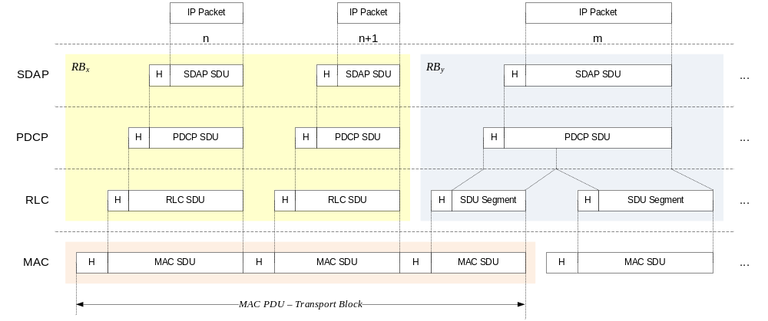
Figure 6.6-1: Data Flow Example

6.7 Carrier Aggregation
LTE Baseline for CA is used here as starting point. Possible changes to accommodate NR to be discussed. For instance, HARQ retransmission handling to be confirmed by RAN1/RAN2.
In case of CA, the multi-carrier nature of the physical layer is only exposed to the MAC layer for which one HARQ entity is required per serving cell as depicted on Figures 6.7-1 and 6.7-2 below:
- In both uplink and downlink, there is one independent hybrid-ARQ entity per serving cell and one transport block is generated per TTI per serving cell in the absence of spatial multiplexing. Each transport block and its potential HARQ retransmissions are mapped to a single serving cell.
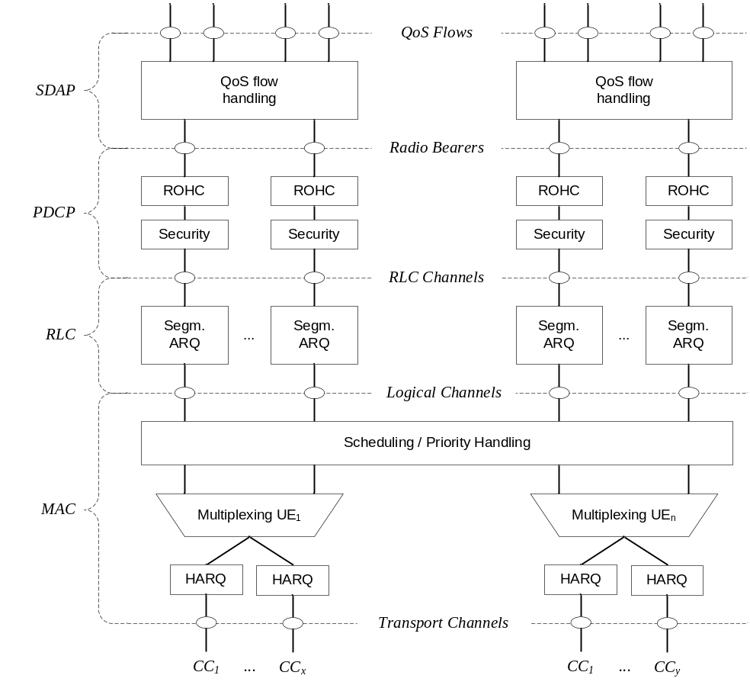
Figure 6.7-1: Layer 2 Structure for DL with CA configured
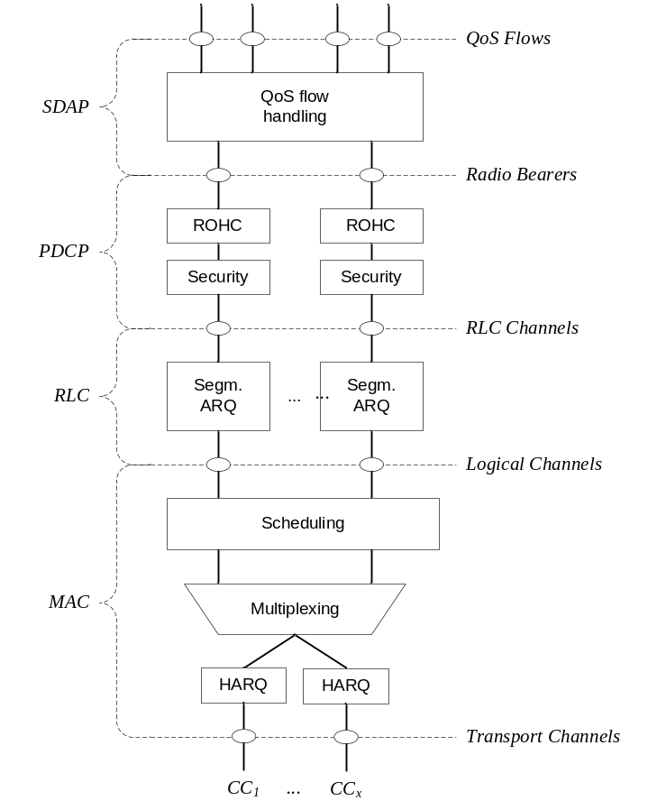
Figure 6.7-2: Layer 2 Structure for UL with CA configured

6.8 Dual Connectivity
LTE Baseline for DC is used here as starting point. Possible changes to accommodate NR to be discussed. FFS whether DC details are capture in 38.300 or 37.340.
In case of DC, the UE is configured with two MAC entities: one MAC entity for the MCG and one MAC entity for the SCG. For a split bearer, UE is configured over which link (or both) the UE transmits UL PDCP PDUs. On the link which is not responsible for UL PDCP PDUs transmission, the RLC layer only transmits corresponding ARQ feedback for the downlink data.

7 RRC

7.1 Services and Functions
The main services and functions of the RRC sublayer include:
- Broadcast of System Information related to AS and NAS;
- Paging initiated by 5GC or NG-RAN;
- Establishment, maintenance and release of an RRC connection between the UE and NG-RAN including:
- Addition, modification and release of carrier aggregation;
- Addition, modification and release of Dual Connectivity in NR or between E-UTRA and NR.
- Security functions including key management;
- Establishment, configuration, maintenance and release of Signalling Radio Bearers (SRBs) and Data Radio Bearers (DRBs);
- Mobility functions including:
- Handover and context transfer;
- UE cell selection and reselection and control of cell selection and reselection;
- Inter-RAT mobility.
- QoS management functions;
- UE measurement reporting and control of the reporting;
- Detection of and recovery from radio link failure;
- NAS message transfer to/from NAS from/to UE.

7.2 Protocol States
RRC supports the following states which can be characterised as follows:
- RRC_IDLE:
- PLMN selection;
- DRX configured by NAS;
- Broadcast of system information;
- Cell re-selection mobility;
- Paging (initiated and area managed by 5GC);
FFS whether the UE AS context is not stored in any gNB or in the UE.
- RRC_INACTIVE:
- Broadcast of system information;
- Cell re-selection mobility;
- 5GC - NG-RAN connection (both C/U-planes) is established for UE;
- The UE AS context is stored in at least one gNB and the UE;
- Paging is initiated by NG-RAN;
- RAN-based notification area is managed by NG- RAN;
- NG-RAN knows the RAN-based notification area which the UE belongs to;
FFS if data transmission in possible in INACTIVE
- RRC_CONNECTED:
- The UE has an NG-RAN RRC connection;
- The UE has an AS context in NG-RAN;
- NG-RAN knows the cell which the UE belongs to;
- Transfer of unicast data to/from the UE;
- Network controlled mobility including measurements.

7.3 System Information Handling
System information is divided into Minimum SI and Other SI. Minimum SI is periodically broadcast and comprises basic information required for initial access and information for acquiring any other SI broadcast periodically or provisioned on-demand, i.e. scheduling information. The Other SI encompasses everything not broadcast in the Minimum SI and may either be broadcast, or provisioned in a dedicated manner, either triggered by the network or upon request from the UE as illustrated in Figure 7.3-1 below.
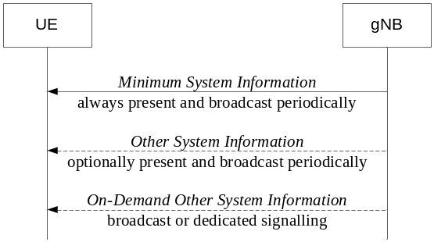
Figure 7.3-1: System Information Provisioning
Exact names pending Stage 3 agreements.
For UEs in RRC_CONNECTED, dedicated RRC signalling is used for the request and delivery of the Other SI. For UEs in RRC_IDLE and RRC_INACTIVE, the request triggers a random access procedure (see subclause 9.2.6) and is carried over MSG3 unless the requested SI is associated to a subset of the PRACH resources, in which case MSG1 can be used. The Other SI may be broadcast at a configurable periodicity and for a certain duration. It is a network decision whether the other SI is broadcast or delivered through dedicated and UE specific RRC signalling.
Each cell on which the UE is allowed to camp broadcasts at least some contents of the Minimum SI, while there may be cells in the system on which the UE cannot camp and do not broadcast the Minimum SI.
For a cell/frequency that is considered for camping by the UE, the UE is not required to acquire the contents of the minimum SI of that cell/frequency from another cell/frequency layer. This does not preclude the case that the UE applies stored SI from previously visited cell(s).
If the UE cannot determine the full contents of the minimum SI of a cell (by receiving from that cell or from valid stored SI from previous cells), the UE shall consider that cell as barred.
When multiple numerologies are mixed on a single carrier, only the default one is used for system information broadcast and paging.
FFS whether initial access from RRC_INACTIVE also relies on the default numerology.

7.4 Access Control
NG-RAN should support overload and access control functionality such as RACH back off, RRC Connection Reject, RRC Connection Release and UE based access barring mechanisms.
One unified access barring mechanism for NR should be introduced to address all the use cases and scenarios that E-UTRA addressed with different specialized mechanisms. The unified access barring mechanism should be forward compatible in order to cope with future use cases/scenarios.
In NR, the unified access barring mechanism should be applicable for all RRC states in NR (RRC_IDLE, RRC_CONNECTED and RRC_INACTIVE).
These are only high level requirements, once the corresponding mechanisms are actually agreed, this subclause should be changed.

7.5 UE Capability Retrieval framework
The UE reports its UE radio access capabilities which are static at least when the network requests. The gNB can request what capabilities for the UE to report (e.g. similar band and band combination requests as in E-UTRAN). The change of UE capabilities is just to, temporarily (e.g. under network control), limit the availability of some capabilities, e.g. due to hardware sharing, interference or overheating. The temporary capability restriction should be transparent to 5GC. Namely, only static capabilities are stored in 5GC. The UE signals the temporary capability restriction request to the gNB.
Should statements require more work.

7.6 Transport of NAS Messages
To be captured once agreements are made.

7.7 Carrier Aggregation
LTE Baseline for CA is used here as starting point. Possible changes to accommodate NR to be discussed. PCell change, activation, re-establishment FFS.
When CA is configured, the UE only has one RRC connection with the network. At RRC connection establishment/re-establishment/handover, one serving cell provides the NAS mobility information, and at RRC connection re-establishment/handover, one serving cell provides the security input. This cell is referred to as the Primary Cell (PCell). Depending on UE capabilities, Secondary Cells (SCells) can be configured to form together with the PCell a set of serving cells. The configured set of serving cells for a UE therefore always consists of one PCell and one or more SCells.
The reconfiguration, addition and removal of SCells can be performed by RRC. At intra-NR handover, RRC can also add, remove, or reconfigure SCells for usage with the target PCell. When adding a new SCell, dedicated RRC signalling is used for sending all required system information of the SCell i.e. while in connected mode, UEs need not acquire broadcasted system information directly from the SCells.

8 NG Identities
Not discussed yet, need inputs from RAN1, RAN3 and SA2.

9 Mobility and State Transitions
FFS whether serving/non-serving cell may be termed 'serving/non-serving set of beam.
FFS how the cell in connected relates to the cell in idle.

9.1 Overview
Load balancing is achieved in NR with handover, redirection mechanisms upon RRC release and through the usage of inter-frequency and inter-RAT absolute priorities and inter-frequency Qoffset parameters.
Measurements to be performed by a UE for connected mode mobility are classified in at least three measurement types:
- Intra-frequency measurements;
- Inter-frequency measurements;
- Inter-RAT measurements;
For each measurement type one or several measurement objects can be defined (a measurement object defines e.g. the carrier frequency to be monitored).
For each measurement object one or several reporting configurations can be defined (a reporting configuration defines the reporting criteria). Three reporting criteria are used: event triggered reporting, periodic reporting and event triggered periodic reporting.
The association between a measurement object and a reporting configuration is created by a measurement identity (a measurement identity links together one measurement object and one reporting configuration of same RAT). By using several measurement identities (one for each measurement object, reporting configuration pair) it is possible:
- To associate several reporting configurations to one measurement object and;
- To associate one reporting configuration to several measurement objects.
The measurements identity is as well used when reporting results of the measurements.
Measurement quantities are considered separately for each RAT.
Measurement commands are used by NG-RAN to order the UE to start measurements, modify measurements or stop measurements.

9.2 Intra-NR

9.2.1 Mobility in RRC_IDLE

9.2.1.1 Cell Selection
The principles of PLMN selection in NR are based on the 3GPP PLMN selection principles. Cell selection is required on transition from RM-DEREGISTERED to RM-REGISTERED, from CM-IDLE to CM-CONNECTED and from CM-CONNECTED to CM-IDLE and is based on the following principles:
- The UE NAS layer identifies a selected PLMN and equivalent PLMNs;
- The UE searches the NR frequency bands and for each carrier frequency identifies the strongest cell. It reads cell system information broadcast to identify its PLMN(s):
- The UE may search each carrier in turn ("initial cell selection") or make use of stored information to shorten the search ("stored information cell selection").
- The UE seeks to identify a suitable cell; if it is not able to identify a suitable cell it seeks to identify an acceptable cell. When a suitable cell is found or if only an acceptable cell is found it camps on that cell and commence the cell reselection procedure:
- A suitable cell is one for which the measured cell attributes satisfy the cell selection criteria; the cell PLMN is the selected PLMN, registered or an equivalent PLMN; the cell is not barred or reserved and the cell is not part of a tracking area which is in the list of "forbidden tracking areas for roaming";
- An acceptable cell is one for which the measured cell attributes satisfy the cell selection criteria and the cell is not barred.
Transition to RRC_IDLE:
On transition from RRC_CONNECTED to RRC_IDLE, a UE should camp on the last cell for which it was in RRC_CONNECTED or a cell/any cell of set of cells or frequency be assigned by RRC in the state transition message.
Recovery from out of coverage:
The UE should attempt to find a suitable cell in the manner described for stored information or initial cell selection above. If no suitable cell is found on any frequency or RAT, the UE should attempt to find an acceptable cell.
In multi-beam operations, measurement quantity of a cell is derived amongst the beams corresponding to the same cell. When multiple numerologies are mixed on a single carrier, only the default one is used for system information broadcast and paging.
FFS how to derive the cell level measurement quantity from multiple beams, which may or needs not be different for the one in RRC_CONNECTED. FFS whether initial access from RRC_IDLE also relies on the default numerology.

9.2.1.2 Cell Reselection
A UE in RRC_IDLE performs cell reselection. The principles of the procedure are the following:
- The UE makes measurements of attributes of the serving and neighbour cells to enable the reselection process:
- For the search and measurement of inter-frequency neighbouring cells, only the carrier frequencies need to be indicated;
- Cell reselection identifies the cell that the UE should camp on. It is based on cell reselection criteria which involves measurements of the serving and neighbour cells:
- Intra-frequency reselection is based on ranking of cells;
- Inter-frequency reselection is based on absolute priorities where a UE tries to camp on the highest priority frequency available.
- An NCL can be provided by the serving cell to handle specific cases for intra- and inter-frequency neighbouring cells.
- Black lists can be provided to prevent the UE from reselecting to specific intra- and inter-frequency neighbouring cells;
- Cell reselection can be speed dependent;
- Service specific prioritisation.
FFS for which services the service specific frequency prioritisation is applied and how it applies for the case of network slices.
In multi-beam operations, measurement quantity of a cell is derived from N best beams corresponding to the same cell where the value of N can be configured to 1 or more than 1.
FFS on details of filtering to be applied (E.g. for the case N = 1, the best beam is filtered by a single filter as the best beam changes) and whether to only consider beams above a threshold (good beams)

9.2.2 Mobility in RRC_INACTIVE

9.2.2.1 Cell Reselection
Can we assume the same principle as for RRC-IDLE?

9.2.2.2 RAN-Based Notification Area
A UE in the RRC_INACTIVE state can be configured with the RAN-based notification area, where:
- a notification area can cover a single or multiple cells, and can be smaller than CN area;
- a "location update" indication is sent by the UE when it leaves the notification area.
There are several different alternatives on how the RAN-based notification area can be configured:
- List of cells;
- A UE is provided an explicit list of cells (one or more) that constitute the RAN-based notification area.
- RAN area.
- A UE is provided (at least one) RAN area ID;
- A cell broadcasts (at least one) RAN area ID in the system information so that a UE knows which area the cell belongs to.
FFS whether one alternative or both are agreed.

9.2.2.3 State Transitions

9.2.2.3.1 UE triggered transition from RRC_INACTIVE to RRC_ACTIVE
Editor’s Note: some general text to be provided, mainly from RAN3. RRC signalling is FFS.
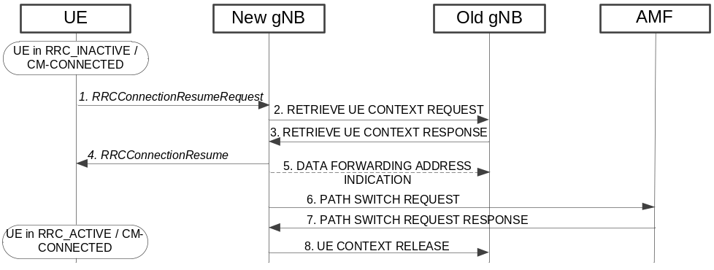
Figure 9.2.2.3.1-1: UE triggered transition from RRC_INACTIVE to RRC_ACTIVE
1. The UE resumes from RRC_INACTIVE, providing the Resume ID, allocated by the old gNB.
Applicability of the term Resume ID for NG-RAN is pending RAN2.
2. The new gNB, if able to resolve the gNB identity contained in the Resume ID, requests the old gNB to provide UE Context data.
Applicability of the term Resume ID for NG-RAN is pending RAN2.
3. The old gNB provides UE context data.
4. The new gNB completes the resumption of the RRC connection.
5. If loss of DL user data buffered in the old serving gNB shall be prevented, the new gNB provides forwarding addresses.
6./7. The new gNB performs path switch.
8. The new gNB triggers the release of the UE resources at the old gNB.
More details to be added.

9.2.2.3.2 Network triggered transition from RRC_INACTIVE to RRC_ACTIVE
Some general text to be provided, mainly from RAN3
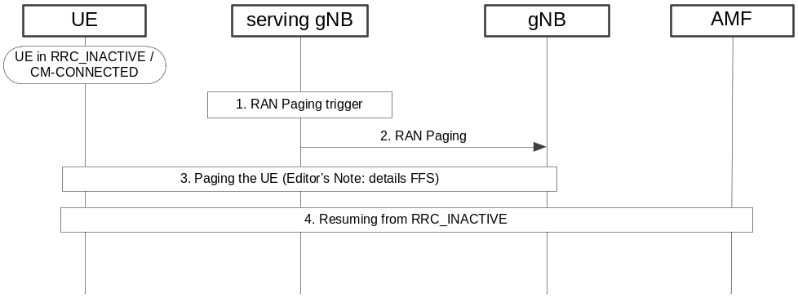
Figure 9.2.2.3.2-1: Network triggered transition from RRC_INACTIVE to RRC_ACTIVE
1. A RAN paging trigger event occurs (incoming DL user plane, DL signalling from 5GC, etc.)
2. RAN paging is triggered; either only in the cells controlled by the serving gNB or also by means of Xn RAN Paging, in other gNBs, being member of the RAN Paging area the UE is registered with.
3. The UE is paged with an NG-RAN allocated UE identity.
Details are FFS.
4. If the UE has been successfully reached, it attempts to resume from RRC_INACTIVE, as described in other sections.
More details to be added.

9.2.3 Mobility in RRC_CONNECTED

9.2.3.1 Overview
Network controlled mobility applies to UEs in RRC_CONNECTED and is categorized into two types of mobility: cell level mobility and beam level mobility.

Cell Level Mobility requires explicit RRC signalling to be triggered, i.e. handover. Handover signalling procedures adopt the same principle as Rel-13 E-UTRAN as specified in TS 36.300 [2]. For inter-gNB handover, the signalling procedures consist of at least the following elemental components illustrated in Figure 10.2.3-1:
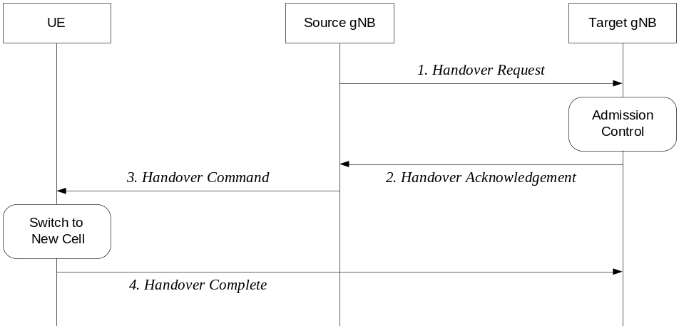
Figure 9.2.3-1: Inter-gNB handover procedures
1. The source gNB initiates handover and issues a Handover Request over the Xn interface.
2. The target gNB performs admission control and provides the RRC configuration as part of the Handover Acknowledgement.
3. The source gNB provides the RRC configuration to the UE in the Handover Command. The Handover Command message includes at least cell ID and all information required to access the target cell so that the UE can access the target cell without reading system information. For some cases, the information required for contention based and contention free random access can be included in the Handover Command message. The access information to the target cell may include beam specific information, if any.
4. The UE moves the RRC connection to the target gNB and replies the Handover Complete.
Exact message name FFS. Further enhancements and modifications can be considered.
The handover mechanism triggered by RRC requires the UE at least to reset the MAC entity and re-establish RLC. For DRBs using RLC AM mode, PDCP can either be re-established together with a security key change or initiate a data recovery procedure without a key change. For DRBs using RLC UM mode and for SRBs, PDCP can either be re-established together with a security key change or remain as it is without a key change.

Data forwarding, in-sequence delivery and duplication avoidance at handover can be guaranteed when the target gNB uses the same DRB configuration and QoS flow to DRB mapping as the source gNB.
FFS whether QoS flow can be remapped at handover and, if supported, whether the handover is lossless in this case.
Beam Level Mobility does not require explicit RRC signalling to be triggered - it is dealt with at lower layers - and RRC is not required to know which beam is being used at a given point in time.
FFS whether there may be cases for which intra-cell mobility needs to be handled by RRC.

9.2.3.2 Handover

9.2.3.2.1 C-Plane Handling
The intra-NR RAN handover performs the preparation and execution phase of the handover procedure performed without involvement of the 5GC, i.e. preparation messages are directly exchanged between the gNBs. The release of the resources at the source gNB during the handover completion phase is triggered by the target gNB. The figure below depicts the basic handover scenario where neither the AMF nor the UPF changes:
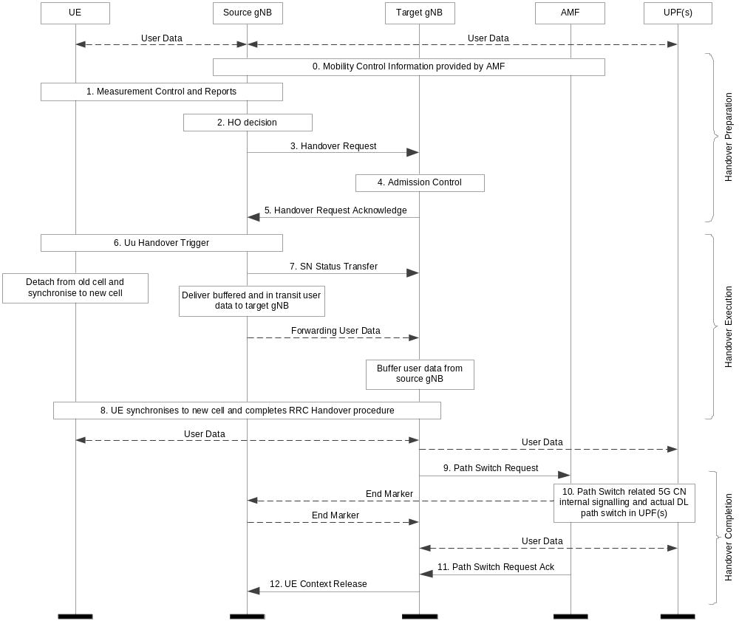
Figure 9.2.3.2.1-1: Intra-AMF/UPF Handover
0. The UE context within the source gNB contains information regarding roaming and access restrictions which were provided either at connection establishment or at the last TA update.
1. The source gNB configures the UE measurement procedures and the UE reports according to the measurement configuration.
2. The source gNB decides to handover the UE, based on MEASUREMENT REPORT and RRM information.
3. The source gNB issues a HANDOVER REQUEST message to the target gNB passing necessary information to prepare the HO at the target side
4. Admission Control may be performed by the target gNB.
5. The target gNB prepares HO with L1/L2 and sends the HANDOVER REQUEST ACKNOWLEDGE to the source gNB.
6. The target gNB generates the RRC message to perform the handover.
7. The source gNB sends the SN STATUS TRANSFER message to the target gNB.
8. The UE synchronises to the target cell and completes the RRC handover procedure.
9. The target gNB sends a PATH SWITCH REQUEST message to AMF to trigger 5GC to switch the DL data path towards the target gNB and to establish an NG-C interface instance towards the target gNB.
10. 5GC switches the DL data path towards the target gNB
11. The AMF confirms the PATH SWITCH REQUEST message with the PATH SWITCH REQUEST ACKNOWLEDGE message.
12. By sending the UE CONTEXT RELEASE message, the target gNB informs the source gNB about the success of HO and triggers the release of resources by the source gNB. The target gNB sends this message after the PATH SWITCH REQUEST ACKNOWLEDGE message is received from the AMF. Upon reception of the UE CONTEXT RELEASE message, the source gNB can release radio and C-plane related resources associated to the UE context. Any ongoing data forwarding may continue.
More details to be added by RAN2 and RAN3 in coordination with SA2.

9.2.3.2.2 U-Plane Handling

9.2.4 Measurements
In RRC_CONNECTED, the UE measures multiple beams (at least one) of a cell and the measurements results are averaged to derive the cell quality. In doing so, the UE is configured to consider a subset of the detected beams: the N best beams. Filtering takes place at two different levels: at the physical layer to derive beam quality and then at RRC level to derive cell quality from multiple beams. Cell quality from beam measurements is derived in the same way for the serving cell(s) and for the non-serving cell(s). Measurement reports may contain the measurement results of the N best beams if the UE is configured to do so by the gNB.
Possible difference between serving and non-serving could be the value of “N” i.e. N best beams - FFS.

9.2.5 Paging
The UE in RRC_IDLE and RRC_INACTIVE states may use DRX in order to reduce power consumption. While in RRC_IDLE the UE monitors 5GC-initiated paging, in RRC_INACTIVE the UE is reachable via RAN-initiated paging and 5GC-initiated paging. RAN and 5GC paging occasions overlap and same paging mechanism is used. The UE monitors one paging occasion per DRX cycle for the reception of paging as follows:
- Paging DRX cycle length is configurable;
- A default DRX cycle for CN paging is configurable via system information;
- A UE specific DRX cycle for CN paging is configurable via UE dedicated signalling;
- An NG-RAN node can configure a UE with a DRX cycle for RAN paging. This configuration can be UE specific.
- The number of paging occasions in a DRX cycle is configurable via system information;
- A network may distribute UEs to the paging occasions based on UE id when multiple paging occasions are configured in the DRX cycle.
- Paging occasion can consist of multiple time slots (e.g. subframe or OFDM symbol). The number of time slots in a paging occasion is configurable via system information.
- A network may transmit a paging using a different set of DL Tx beam(s) or repetitions in each time slot.
Transmission mechanism of paging in each time slot is up to RAN1 decision. Content of paging (e.g. paging message or paging indicator) is FFS when using beam sweeping.

9.2.6 Random Access Procedure
The random access procedure is triggered by a number of events, for instance:
- Initial access from RRC_IDLE;
- RRC Connection Re-establishment procedure;
- Handover;
- DL or UL data arrival during RRC_CONNECTED when UL synchronisation status is "non-synchronised";
- Transition from RRC_INACTIVE.
Furthermore, the random access procedure takes two distinct forms: contention based and non-contention based as shown on Figure 9.2-1 below. Normal DL/UL transmission can take place after the random access procedure.
RAN2 should strive for as much commonality in random access procedure as possible across all use cases.
FFS whether the gNB can be provided with more information (compared to LTE) from the UE on the Msg.3 to provide.
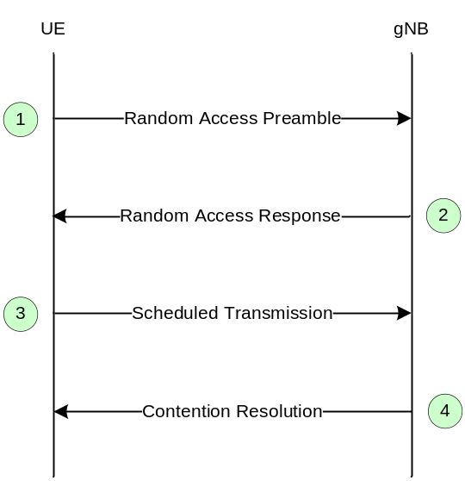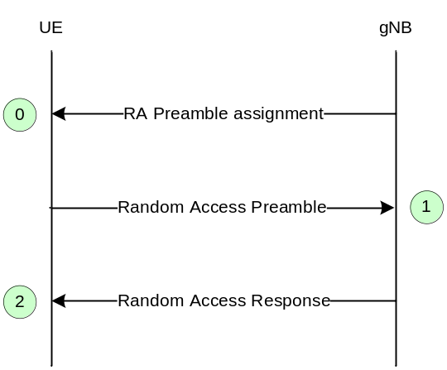
(a) Contention Based (b) Contention Free
Figure 9.2.5-1: Random Access Procedures
More details can be added like in LTE if required (once agreed).

9.2.7 Radio Link Failure
In RRC_CONNECTED, the UE declares Radio Link Failure (RLF) when one of the following criteria are met:
- Expiry of a timer started after indication of radio problems from the physical layer;
- Random access procedure failure;
- Maximum number of retransmissions reached for one DRB using RLC AM.
For RLC, it is FFS whether this is the only criteria.

9.3 Inter RAT

9.3.1 Cell Reselection
Cell reselection is characterised by the following:
- Cell reselection between NR RRC_IDLE and E-UTRA RRC_IDLE is supported;

9.3.2 Handover
Inter RAT mobility is characterised by the following:
- Source RAT should be able to support and configure Target RAT measurement and reporting.
Inter RAT mobility within NG-RAN is characterised further by the following:
- The in-sequence and lossless handover is supported for the handover between RAN nodes of NG-RAN (eNB and gNB).
Inter RAT mobility between 5GC and EPC is characterised further by the following:
- Both Xn and CN handover between E-UTRA connected to 5GC and NR is supported. The target RAT receives the UE NG-C context information and based on this information configures the UE with a complete RRC message and Full configuration (not delta). Whether the handover is over Xn or CN is transparent to the UE.
Support for HO between NR and LTE connected to EPC depends on SA2 decisions and support of NGx with context mapping between 5GC and EPC. If supported, from RAN2 perspective, a “conventional” S1/NG based HO procedure is used where the target RAT receives the UE S1 context information and based on this information configures the UE with a complete RRC message and Full configuration (not delta).

9.3.3 Measurements
To be captured once agreements are made.

9.4 Roaming and Access Restrictions
The description detail needs further check, e.g., whether more restriction information is needed.
The roaming and access restriction information for a UE includes information on restrictions to be applied for subsequent mobility action during CM-CONNECTED state. It may be provided by the AMF and also may be updated by the AMF later.
It includes the forbidden RAT, the forbidden area and the service area restrictions as specified in 3GPP TS 23.501 [3]. It also includes serving PLMN and may include a list of equivalent PLMNs.
Upon receiving the roaming and access restriction information for a UE, if applicable, the gNB should use it to determine whether to apply restriction handling for subsequent mobility action, e.g., handover, redirection.
If the roaming and access restriction information is not available for a UE at the gNB, the gNB shall consider that there is no restriction for subsequent mobility actions.
The received roaming and access restriction information should be propagated over Xn by the source gNB during Xn handover.

10 Scheduling

10.1 Basic Scheduler Operation
In order to utilise radio resources efficiently, MAC in gNB includes dynamic resource schedulers that allocate physical layer resources for the downlink and the uplink. In this subclause, an overview of the scheduler is given in terms of scheduler operation, signalling of scheduler decisions, and measurements.
Scheduler Operation:
- Taking into account the UE buffer status and the QoS requirements of each UE and associated radio bearers, schedulers assign resources between UEs;
- Schedulers may assign resources taking account the radio conditions at the UE identified through measurements made at the gNB and/or reported by the UE;
- Schedulers assign radio resources in a unit of TTI (e.g. one mini-slot, one slot, or multiple slots);
- Resource assignment consists of radio resources (resource blocks).
Signalling of Scheduler Decisions:
- UEs identify the resources by receiving a scheduling (resource assignment) channel.
Measurements to Support Scheduler Operation:
- Uplink buffer status reports (measuring the data that is buffered in the logical channel queues in the UE) are used to provide support for QoS-aware packet scheduling.
- The buffer reporting scheme used in uplink is flexible to support different types of data services. Constraints on how often uplink buffer reports are signalled from the limits the overhead from sending the reports in the uplink.

10.2 Downlink Scheduling
In the downlink, the gNB can dynamically allocate resources to UEs at each TTI. A UE always monitors the downlink in order to find possible allocation when its downlink reception is enabled (activity governed by DRX when configured). In addition, NR can periodically allocate semi-persistent downlink resources for the first HARQ transmissions to UEs via RRC.
More details on possible channel names, SPS and retransmission handling can be added if agreed/needed.

10.3 Uplink Scheduling
In the uplink, the gNB can dynamically allocate resources to UEs at each TTI. A UE always monitors the downlink in order to find possible allocation for uplink transmission when its downlink reception is enabled (activity governed by DRX when configured). In addition, NR can periodically allocate semi-persistent uplink resources for the first HARQ transmissions to UEs via RRC.
More details on possible channel names, SPS and retransmission handling can be added if agreed/needed.

10.4 Measurements to Support Scheduler Operation
Measurement reports are required to enable the scheduler to operate in both uplink and downlink. These include transport volume and measurements of a UEs radio environment.
Uplink buffer status reports (BSR) are needed to provide support for QoS-aware packet scheduling. In NR, uplink buffer status reports refer to the data that is buffered in for a group of logical channel (LCG) in the UE. Four LCGs and two formats are used for reporting in uplink:
- A short format for which only one BSR (of one LCG) is reported;
- A long format for which all four BSRs (of all four LCGs) are reported.
Uplink buffer status reports are transmitted using MAC signalling.
In DC, the BSR configuration, triggering and reporting are independently performed per CG. For split bearers, the PDCP data is considered in BSR in the CG(s) configured by RRC.
LTE baseline captured. Further enhancements at least related to numerologies and granularity to be discussed.

10.5 Rate Control
To be captured once agreements are made.

10.6 Activation/Deactivation Mechanism
LTE Baseline for CA is used here as starting point. Possible changes to accommodate NR to be discussed, for instance initial the state of the SCells.
To enable reasonable UE battery consumption when CA is configured, an activation/deactivation mechanism of Cells is supported. When a Cell is deactivated, the UE does not need to receive the corresponding PDCCH or PDSCH, cannot transmit in the corresponding uplink, nor is it required to perform CQI measurements. Conversely, when a Cell is active, the UE shall receive PDSCH and PDCCH (if the UE is configured to monitor PDCCH from this SCell), and is expected to be able to perform CQI measurements.
At reconfiguration without mobility control information:
- SCells added to the set of serving cells are initially deactivated;
- SCells which remain in the set of serving cells (either unchanged or reconfigured) do not change their activation status (activated or deactivated).
At reconfiguration with mobility control information (i.e. handover):
- SCells are deactivated.

11 UE Power Saving
LTE Baseline for DRX is used here as starting point. Possible changes to accommodate NR to be discussed.
The PDCCH monitoring activity of the UE is governed by DRX. When DRX is configured, the UE does not have to continuously monitor PDCCH. DRX is characterized by the following:
- on-duration: duration that the UE waits for, after waking up, to receive PDCCHs. If the UE successfully decodes a PDCCH, the UE stays awake and starts the inactivity timer;
- inactivity-timer: duration that the UE waits to successfully decode a PDCCH, from the last successful decoding of a PDCCH, failing which it can go back to sleep. The UE shall restart the inactivity timer following a single successful decoding of a PDCCH for a first transmission only (i.e. not for retransmissions).
- retransmission-timer: duration until a retransmission can be expected.
- cycle: specifies the periodic repetition of the on-duration followed by a possible period of inactivity (see figure 11-1 below).
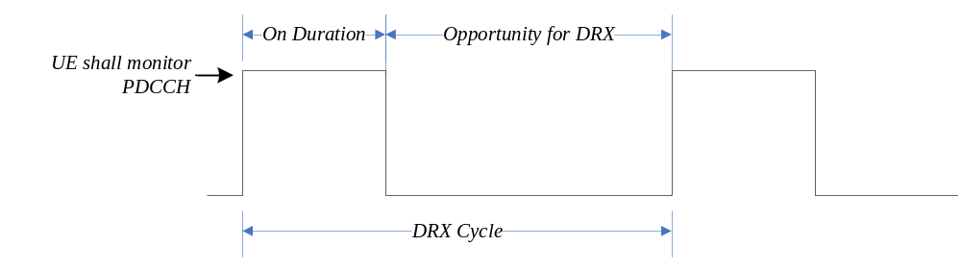
Figure 11-1: DRX Cycle
PDCCH naming needs to be confirmed.

12 QoS
The QoS architecture in NG-RAN is depicted in the Figure 13-1 and described in the following:
- For each UE, 5GC establishes one or more PDU Sessions.
- For each UE, the NG-RAN establishes one or more Data Radio Bearers (DRB) per PDU Session. The NG-NG-RAN maps packets belonging to different PDU sessions to different DRBs. Hence, the NG-RAN establishes at least one default DRB for each PDU Session indicated by 5GC upon PDU Session establishment.
- NAS level packet filters in the UE and in the 5GC associate UL and DL packets with QoS Flows.
- AS-level mapping in the UE and in the NG-RAN associate UL and DL QoS Flows with DRBs.
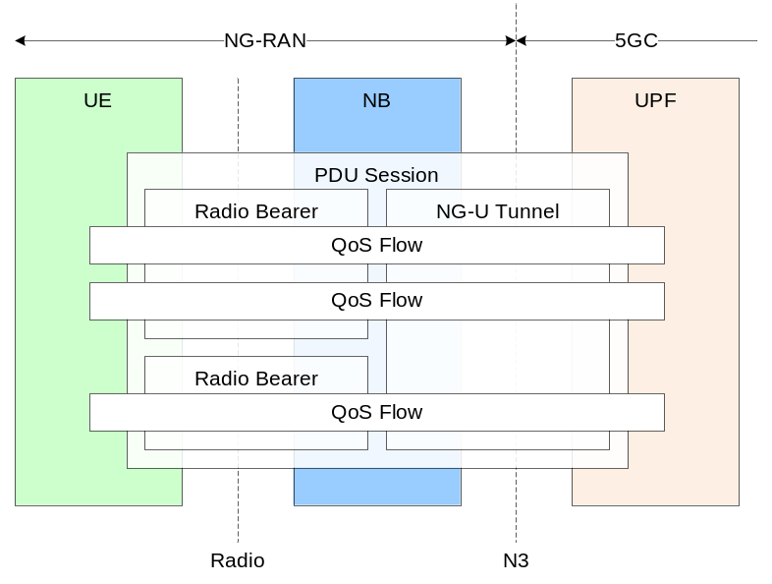
Figure 12-1: QoS architecture
NG-RAN and 5GC ensure quality of service (e.g. reliability and target delay) by mapping packets to appropriate QoS Flows and DRBs. Hence there is a 2-step mapping of IP-flows to QoS flows (NAS) and from QoS flows to DRBs (Access Stratum).
In NG-RAN, the data radio bearer (DRB) defines the packet treatment on the radio interface (Uu). A DRB serves packets with the same packet forwarding treatment. Separate DRBs may be established for QoS flows requiring different packet forwarding treatment. In the downlink, the NG-RAN maps QoS Flows to DRBs based on NG-U marking (QoS Flow ID) and the associated QoS profiles. In the uplink, the UE marks uplink packets over Uu with the QoS flow ID for the purposes of marking forwarded packets to the CN.
In the uplink, the NG-RAN may control the mapping of QoS Flows to DRB in two different ways:
- Reflective mapping: for each DRB, the UE monitors the QoS flow ID(s) of the downlink packets and applies the same mapping in the uplink; that is, for a DRB, the UE maps the uplink packets belonging to the QoS flows(s) corresponding to the QoS flow ID(s) and PDU Session observed in the downlink packets for that DRB. To enable this reflective mapping, the NG-RAN marks downlink packets over Uu with QoS flow ID.
It is FFS whether the marking with a QoS flow ID can be semi-statically configured (to not include the QOS flow ID when not needed).
- Explicit Configuration: besides the reflective mapping, the NG-RAN may configure by RRC an uplink “QoS Flow to DRB mapping”.
The precedence of the RRC configured mapping and reflective QoS is FFS (can reflective QoS update and thereby override an RRC configured mapping? Or does a configured QoS Flow ID to DRB mapping always take precedence over a reflective mapping?)
If an incoming UL packet matches neither an RRC configured nor a reflective “QoS Flow ID to DRB mapping”, the UE shall map that packet to the default DRB of the PDU session.
Within each PDU session, is up to NG-RAN how to map multiple QoS flows to a DRB. The NG-RAN may map a GBR flow and a non-GBR flow, or more than one GBR flow to the same DRB, but mechanisms to optimise these cases are not within the scope of standardization. The timing of establishing non-default DRB(s) between NG-RAN and UE for QoS flow configured during establishing a PDU session can be different from the time when the PDU session is established. It is up to NG-RAN when non-default DRBs are established.
In DC, the QoS flows belonging to the same PDU session can be mapped to different bearer types (see subclause 4.5.2) and as a result there can be two different SDAP entities configured for the same PDU session: one for MCG and another one for SCG (for instance when one MCG bearer and one SCG bearer are used for two different QoS flows).
The support for PDU session mapped to different bearers is pending conclusions in SA2 and RAN3.

13 Security
Security key refresh is not performed at every mobility procedure (i.e. handover), at least for the case of mobility where the PDCP anchor point is not changed.
It is to be confirmed by SA3 considering whether it has any implication on the inputs for key derivation, e.g. PCI.

14 Network Interfaces
To be provided by RAN3. Should contain an overview of the network interfaces. Coordination with SA2 expected, but from RAN3 side.

15 CU/DU Split
Overview of CU/DU split to be provided in cooperation with RAN3.

16 UE Capabilities
To be captured once agreements are made.

17 Verticals Support

17.1 Self-Configuration and Self-Optimisation

17.1.1 Definitions
Text similar to section 22.1 of 36.300. Needs to be probably revisited

17.1.2 UE Support for self-configuration and self-optimisation
Text similar to section 22.2 of 36.300. Needs to be probably revisited.

17.1.3 Self-configuration

17.1.3.1 Dynamic configuration of the NG-C interface

17.1.3.1.1 Prerequisites
The following prerequisites are assumed:
- An initial remote IP end point to be used for SCTP initialisation is provided to the gNB for each AMF the gNB is supposed to connect to.
How the gNB gets the remote IP end point(s) and its own IP address are outside the scope of this specification.
Further 5GC functions, like provision of further AMF pool information and other concepts that may come from SA2 are FFS.

17.1.3.1.2 SCTP initialization
This is a place holder, text similar to section 22.3.1.2 of 36.300.

17.1.3.1.3 Application layer initialization
Once SCTP connectivity has been established, the gNB and the AMF shall exchange application level configuration data over the NG-C application protocol with the NG Setup Procedure, which is needed for these two nodes to interwork correctly on the NG interface.
- The gNB provides the relevant configuration information to the AMF, which includes list of supported TA(s), etc.
- The AMF provides the relevant configuration information to the gNB, which includes PLMN ID, etc.
- When the application layer initialization is successfully concluded, the dynamic configuration procedure is completed and the NG-C interface is operational.
Text similar to TS 36.300 seems to be sufficient description on that level, further input is FFS.

17.1.3.2 Dynamic Configuration of the Xn interface

17.1.3.2.1 Prerequisites
The following prerequisites are necessary:
- An initial remote IP end point to be used for SCTP initialisation is provided to the gNB.

17.1.3.2.2 SCTP initialization
This is a place holder, text similar to section 22.3.2.2 of TS 36.300.

17.1.3.2.3 Application layer initialization
Once SCTP connectivity has been established, the gNB and its candidate peer gNB are in a position to exchange application level configuration data over the Xn application protocol needed for the two nodes to interwork correctly on the Xn interface.
Note, that Xn Setup would have to cater for E-UTRA and NR RAT. This may also be expected to be reflected in the definition of the gNB ID. Another aspect is the fact that one cell of a certain RAT may have neighbours from 2 different RATs. Also the current mandate of reporting *all* served cells might need to be revisited. Further details are FFS.

17.1.3.3 Automatic Neighbour Relation Function

17.1.3.3.1 General
The purpose of the Automatic Neighbour Relation (ANR) function is to relieve the operator from the burden of manually managing Neighbour Relations (NRs).
Further details FFS, text similar to section 22.3.2a of TS 36.300.

17.1.3.3.2 Intra-system – intra NR Automatic Neighbour Relation Function
If PCI concept is inherited by NR (and there is some likelihood that this is the case), probably this chapter can be merged with the intra-E-UTRA chapter. Expected to contain similar text (apart from interface and RAT specific adaptations) section 22.3.3 of TS 36.300.

17.1.3.3.3 Intra-system – intra E-UTRA Automatic Neighbour Relation Function
Expected to contain a text similar as section 22.3.3 of TS 36.300.

17.1.3.3.4 Intra-system – inter RAT Automatic Neighbour Relation Function
This could be a short chapter describing the necessity for UEs to report inter-RAT neighbours within the NG-RAN.

17.1.3.3.5 Inter-system Automatic Neighbour Relation Function
This chapter to show inter-RAT (NR-E-UTRA) and intra-RAT (E-UTRA – E-UTRA) ANR between NG-RAN and E-UTRAN (only).

17.1.3.4 Xn-C TNL address discovery
If the gNB is aware of the gNB ID of the candidate gNB (e.g. via the ANR function) but not of a TNL address suitable for SCTP connectivity, then the gNB can utilize the 5GC (an AMF it is connected to) to help resolving the TNL address.
Text, similar to TS 36.300 is expected.

17.2 IMS Voice
The WID limits the support to IMS voice. To be captured once agreements are made.

17.3 Network Slicing

17.3.1 General Principles and Requirements
In this sub clause, the general principles and requirements related to the realization of network slicing in the NG-RAN are given.
Support of Network Slicing relies on the principle that traffic for different slices is handled by different PDU sessions. Network can realise the different network slices by scheduling and also by providing different L1/L2 configurations. UE should be able to provide assistance information for network slice selection in RRC message, if it has been provided by NAS.
NOTE 1: It is FFS whether it is possible to provide different PRACH, access barring and congestion control information for different slices.
NOTE 2: The above agreements and FFS are also applicable for E-UTRA connected to 5GC.
Network Slicing is a concept to allow differentiated treatment depending on each customer requirements. With slicing, it is possible for Mobile Network Operators (MNO) to consider customers as belonging to different tenant types with each having different service requirements that govern in terms of what slice types each tenant is eligible to use based on Service Level Agreement (SLA) and subscriptions.
NSSAI (Network Slice Selection Assistance Information) includes one or more S-NSSAIs (Single NSSAI). Each network slice is uniquely identified by a S-NSSAI, as defined in TS 23.501 [3].
The following key principles apply for support of Network Slicing in NG-RAN:
RAN awareness of slices
- NG-RAN supports a differentiated handling of traffic for different network slices which have been pre-configured. How NG-RAN supports the slice enabling in terms of NG-RAN functions (i.e. the set of network functions that comprise each slice) is implementation dependent.
Selection of RAN part of the network slice
- NG-RAN supports the selection of the RAN part of the network slice, by assistance information provided by the UE or the 5GC which unambiguously identifies one or more of the pre-configured network slices in the PLMN.
Resource management between slices
- NG-RAN supports policy enforcement between slices as per service level agreements. It should be possible for a single NG-RAN node to support multiple slices. The NG-RAN should be free to apply the best RRM policy for the SLA in place to each supported slice.
Support of QoS
- NG-RAN supports QoS differentiation within a slice.
RAN selection of CN entity
- For initial attach, the UE may provide assistance information to support the selection of an AMF. If available, NG-RAN uses this information for routing the initial NAS to an AMF. If the UE does not provide any such information the NG-RAN sends the NAS signalling to a default AMF.
- For subsequent accesses, the UE provides a Temp ID, which is assigned to the UE by the 5GC, to enable the NG-RAN to route the NAS message to the appropriate AMF as long as the Temp ID is valid (NG-RAN is aware of and can reach the AMF which is associated with the Temp ID). Otherwise, the methods for initial attach applies.
Resource isolation between slices
- the NG-RAN supports resource isolation between slices. NG-RAN resource isolation may be achieved by means of RRM policies and protection mechanisms that should avoid that shortage of shared resources in one slice breaks the service level agreement for another slice. It should be possible to fully dedicate NG-RAN resources to a certain slice. How NG-RAN supports resource isolation is implementation dependent.
Slice Availability
- Some slices may be available only in part of the network. Awareness in the NG-RAN of the slices supported in the cells of its neighbours may be beneficial for inter-frequency mobility in connected mode. It is assumed that the slice configuration does not change within the UE’s registration area.
- The NG-RAN and the 5GC are responsible to handle a service request for a slice that may or may not be available in a given area. Admission or rejection of access to a slice may depend by factors such as support for the slice, availability of resources, support of the requested service by other slices.
Support for UE associating with multiple network slices simultaneously
- In case a UE is associated with multiple slices simultaneously, only one signalling connection is maintained.
Granularity of slice awareness
- Slice awareness in NG-RAN is introduced at PDU session level, by indicating the S-NSSAI corresponding to the PDU Session, in all signalling containing PDU session resource information.
Validation of the UE rights to access a network slice
- It is the responsibility of the 5GC to validate that the UE has the rights to access a network slice. Prior to receiving the Initial Context Setup Request message, the NG-RAN may be allowed to apply some provisional/local policies, based on awareness of which slice the UE is requesting access to. During the initial context setup, the NG-RAN is informed for all network slices for which resources are being requested.

17.3.2 CN Instance and NW Slice Selection

17.3.2.1 CN-RAN interaction and internal RAN aspects
NG-RAN selects AMF based on a Temp ID or assistance information provided by the UE over RRC. The mechanisms used in the RRC protocol are described in the next sub clause.
Table 17.3.2.1-1 AMF selection based on Temp ID and assistance information
Temp ID | Assistance Info | AMF Selection by NG-RAN
not available or invalid | not available | Default AMF is selected
not available or invalid | present | Selects AMF which supports UE requested slices
valid | not available, or present | Selects AMF per CN identity information in Temp ID

17.3.2.2 Radio Interface Aspects

17.3.3 Resource Isolation and Management
Resource isolation enables specialized customization and avoids one slice affecting another slice.
Hardware/software resource isolation is up to implementation. Each slice may be assigned with either shared or dedicated radio resource up to RRM implementation and SLA.
To enable differentiated handling of traffic for network slices with different SLA:
- NG-RAN is configured with a set of different configurations for different network slices;
- To select the appropriate configuration for the traffic for each network slice, NG-RAN receives relevant information indicating which of the configurations applies for this specific network slice.

17.3.4 Signalling Aspects

It is FFS whether signalling procedures will be kept in this section or moved to other sections describing procedures.

17.3.4.1 General
In this sub clause, signalling flows related to the realization of network slicing in the NG-RAN are given.

17.3.4.2 CN Instance and NW Slice Selection
RAN selects AMF based on a Temp ID or assistance information provided by the UE over RRC.
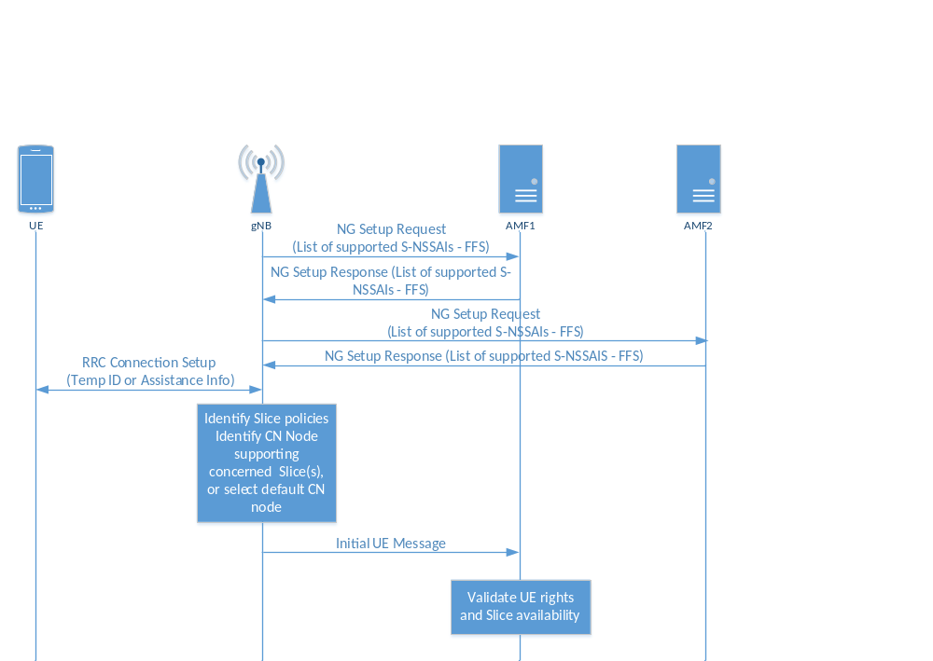 Figure 17.3.4.1-1: AMF instance selection
In case a Temp ID is not available, the RAN uses the information provided by the UE during RRC connection establishment to select the appropriate AMF instance (details are FFS and subject to RAN2 standardization). If such information is also not available, the RAN routes the UE to a default AMF instance.

17.3.4.3 UE Context Handling
Following the initial access, the establishment of the RRC connection and the selection of the correct AMF, the AMF establishes the complete UE context by sending the Initial Context Setup Request message to the NG-RAN over NG-C. The message contains the S-NSSAI as part of the PDU session/s resource description. Upon successful establishment of the UE context and allocation of PDU resources to the relevant NW slice/s, the NG-RAN responds with the Initial Context Setup Response message.
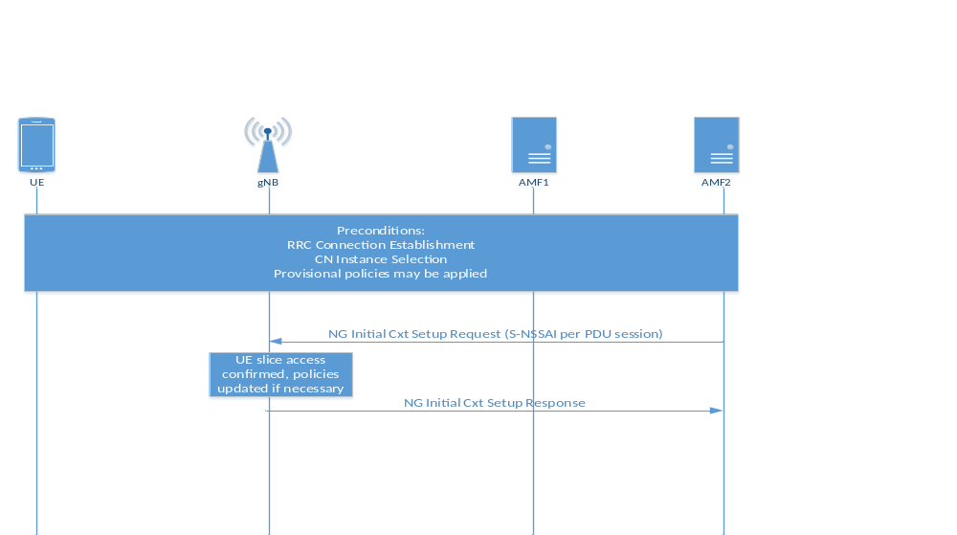

Figure 17.3.4.3-1: Network Slice-aware Initial Context Setup

17.3.4.4 PDU Session Handling
When new PDU sessions need to be established or existing ones modified or released, the 5GC requests the NG-RAN to allocate/release resources relative to the relevant PDU sessions by means of the PDU Session Setup/Modify/Release procedures over NG-C. In case of network slicing, S-NSSAI information is added per PDU session, so NG-RAN is enabled to apply policies at PDU session level according to the SLA represented by the network slice, while still being able to apply (for example) differentiated QoS within the slice.
NG-RAN confirms the establishment/modification/release of a PDU session associated to a certain NW slice by responding with the PDU Session Setup/Modify/Release Response message over the NG-C interface.
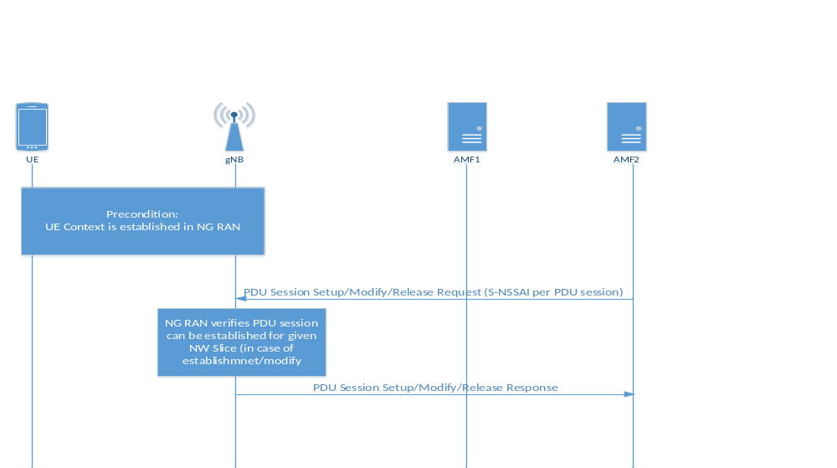
Figure 17.3.4.3-1: Network Slice-aware PDU Session Setup/Modify/Release

17.3.4.5 Mobility
To make mobility slice-aware in case of Network Slicing, S-NSSAI is introduced as part of the PDU session information that is transferred during mobility signalling. This enables slice-aware admission and congestion control.
An example for the case of active mode mobility across different Registration Areas, is shown in Figure 17.3.4.5-1 for the case of 5GC involved handover.
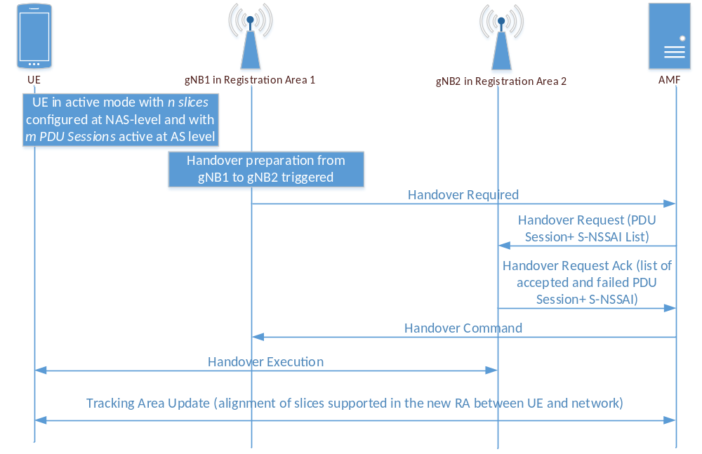
Figure 17.3.4.5-1: Active mode CN involved mobility across different Registration Areas

17.3 PWS
To be captured once agreements are made.

17.4 URLLC
To provide an overview of the mechanisms agreed for URLLC.

Annex Z (informative):
Change history

Change history
Date | Meeting | TDoc | CR | Rev | Cat | Subject/Comment | Version
2017.03 | RAN2 97bis | R2-1702627 | - | - | - | First version. | 0.1.0
2017.04 | RAN2 97bis | R2-1703825 | - | - | - | Editorial Updates:  - Stage 2 Details of ARQ operation marked as FFS  - Placeholder for CU/DU Split overview added  - Outdated editor notes removed  - Protocol Architecture updated  - NG-RAN terminology aligned  - Header placement in the L2 overview put as FFS | 0.1.1
2017.04 | RAN2 97bis | R2-1703952 | - | - | - | Editorial Updates:  - description of measurements for mobility clarified  - some cell reselection details put FFS  - outdated references removed | 0.1.2
2017.04 | RAN2 98 | R2-1704296 | - | - | - | Editorial updates:  - NG interfaces naming aligned to RAN3  - 5GC used consistently  - Statement on lossless delivery removed from 9.3.2  - Overview of PDCP function for CP detailed | 0.1.3
2017.05 | RAN2 98 | R2-1704298 | - | - | - | Agreements of RAN2#97bis captured:  - overview of duplication operation  - RLC modes for DRBs and SRBs  - Condition for lossless mobility  - L2 handling at handover  - RLF triggers  - Measurement details (filtering, beams, quality…)  - QoS flow handling in DC  - RACH procedure message usage for on-demand SI  - Random Access Procedure triggers  - DRX baseline | 0.2.0
2017.05 | RAN2 98 | R2-1704452 | - | - | - | RAN3 agreements captured (R3-171329)  5G logo and specification title updated | 0.2.1

